

**OPERATING SYSTEM PROJECT**

**Dining Philosopher**

**PROBLEM**

**Group Members:**

1. Sohaib Sarosh Shamsi(21k-3278)
2. Haris Kabir(21K-3291)
3. Syed Hadi Arshad (21K-3326)

**Abstract:**

This Project intends to apply the concepts learnt in process synchronization to solve the Dining-Philosophers Problem.

**Problem Statement:**

**The Dining Philosopher Problem –** The Dining Philosopher Problem states that K philosophers seated around a circular table with one chopstick between each pair of philosophers. There is one chopstick between each philosopher. A philosopher may eat if he can pick up the two chopsticks adjacent to him. One chopstick may be picked up by any one of its adjacent followers but not both.

**Program Structure:**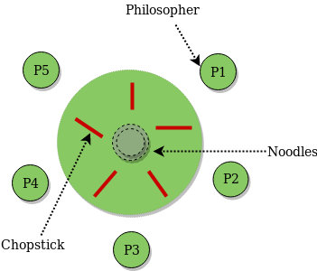

**Technologies used in the Project:**

1. Linux Operating System
2. VmWare virtual machine

**THE END**